PROJECT FINAL REPORT

Project Title: HouseHunt: Finding Your Perfect Rental Home
Submitted by: Supriya Kanchi
Medapati Jagan Mohan
Naga Venkata Sri Lakshmi Nakka
Nagendra Venu Rekapalli
College Name: Swarnandhra College of Engineering and Technology
Team Id: LTVIP2026TMIDS49386

Contents:

S.No | Section | Sub-Sections
1 | INTRODUCTION | 1.1 Project Overview  1.2 Purpose
2 | IDEATION PHASE | 2.1 Problem Statement  2.2 Empathy Map Canvas  2.3 Brainstorming
3 | REQUIREMENT ANALYSIS | 3.1 Customer Journey Map  3.2 Solution Requirement  3.3 Data Flow Diagram  3.4 Technology Stack
4 | PROJECT DESIGN | 4.1 Problem Solution Fit  4.2 Proposed Solution  4.3 Solution Architecture
5 | PROJECT PLANNING &  SCHEDULING | 5.1 Project Planning
6 | FUNCTIONAL AND  PERFORMANCE TESTING | 6.1 Performance Testing
7 | RESULTS | 7.1 Output Screenshots
8 | ADVANTAGES &  DISADVANTAGES
9 | CONCLUSION
10 | FUTURE SCOPE
11 | APPENDIX | Source Code (if any) Dataset Link GitHub &  Project Demo Link

1. INTRODUCTION
In today’s fast-paced and digitally driven world, the process of finding suitable rental property remains a significant challenge for many individuals and families. From the struggle of identifying legitimate listings to coordinating with multiple intermediaries, the traditional approach to house hunting is often time-consuming, inefficient, and emotionally draining.
To address these inefficiencies, “House Hunt – Finding Your Perfect Rental Home” emerges as a modern, intuitive solution designed to simplify the rental journey. This platform acts as a digital bridge between property owners and potential renters, offering a streamlined, user-friendly, and secure environment for all stakeholders involved. The goal is not to replace the values of traditional renting practices but to enhance and transform them through the integration of cutting-edge technology.

1.1 Project Overview
House Hunt is a comprehensive web-based application developed using the MERN stack— MongoDB, Express.js, React.js, and Node.js. It is designed to serve as a one-stop platform for rental property management and discovery, addressing the key pain points faced by both renters and property owners.
The application supports role-based access, allowing users to register and interact with the system as:
- Renters, who can browse and search for rental properties based on customizable filters such as location, budget, and amenities.
- Owners, who can list their properties, update availability, and manage booking requests.
- Administrators, who oversee platform activity, manage listings, and ensure compliance and security.
The system includes essential features such as secure user authentication, real-time property updates, responsive design for cross-device accessibility, and an admin dashboard to monitor user engagement and property data. By incorporating these functionalities, House Hunt provides seamless experience for users and fosters trust and transparency in the rental process.
Whether it is a student searching for affordable accommodation near a university, a working professional relocating to a new city, or a landlord seeking to advertise a vacant home—House Hunt ensures a smooth, efficient, and reliable rental experience for all.

1.2 Purpose
The primary purpose of House Hunt is to streamline the property rental process, making it more accessible, transparent, and efficient. Traditional house-hunting often involves middlemen, scattered listings, and lack of real-time updates. This platform seeks to eliminate those hurdles by:
- Offering a centralized space for renters and owners to connect.
- Minimizing communication gaps and reducing dependency on brokers.
- Providing renters with filtered search options based on location, price, and amenities.
- Empowering owners to manage property listings and approve bookings directly.
- Giving admins tools to monitor user activity, approve listings, and ensure platform security.
Through this project, we aim to blend the reliability of traditional renting practices with the efficiency of modern web applications, creating a balanced and trustworthy rental ecosystem.

2. IDEATION PHASE
The ideation phase marks the foundation of the project’s conceptual development. It involves identifying the real-world challenges in the current house rental process, understanding user needs, and exploring creative solutions that bridge the gap between problems and technology.

2.1 Problem Statement
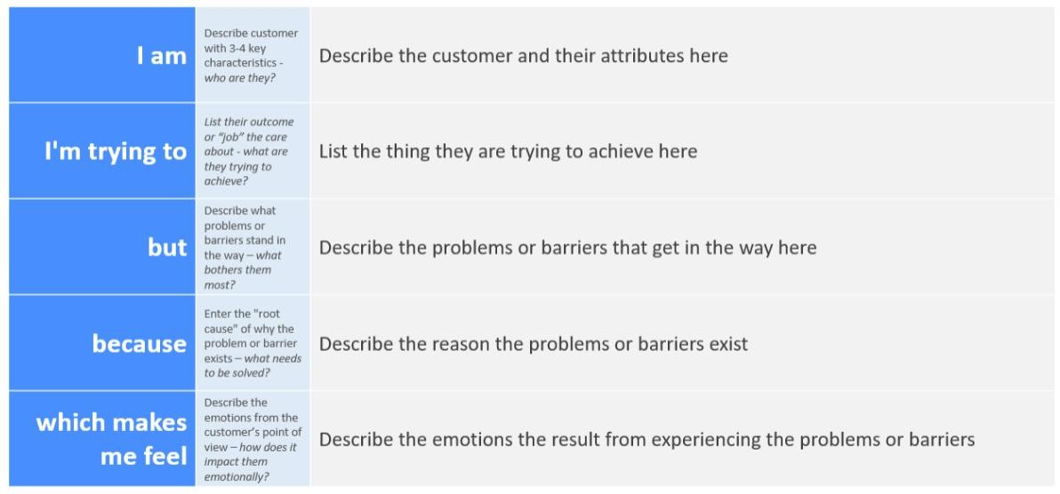

PS-1
I am a student or working professional relocating to a new city.
I’m trying to: find a clean, affordable rental property that suits my budget and preferences.
But: I keep finding outdated or fake listings across multiple websites, and there’s no centralized or trusted platform.
Because: most rental platforms don’t verify listings or provide real-time availability and direct communication with the property owner.
Which makes me feel frustrated, uncertain, and anxious about making the wrong decision or being scammed.

PS-2
I am: A property owner looking to rent out my house or apartment.
I’m trying to: list my property online and connect with genuine tenants quickly.
But: I find it difficult to manage multiple listings, track inquiries, and filter serious renters from casual ones.
Because: there is no streamlined platform that offers admin approval, booking management, and renter verification.
Which makes me feel: overwhelmed and uncertain about whether my property will be rented safely and efficiently.

2.2 Empathy Map Canvas
Empathy Map: An empathy map is a simple, easy-to-digest visual that captures knowledge about a user’s behaviours and attitudes. It is a useful tool to help teams better understand their users.
Creating an effective solution requires understanding the true problem and the person who is experiencing it. The exercise of creating the map helps participants consider things from the user’s perspective along with his or her goals and challenges. EXAMPLE: House Hunt: Finding Your Perfect
Rental Home

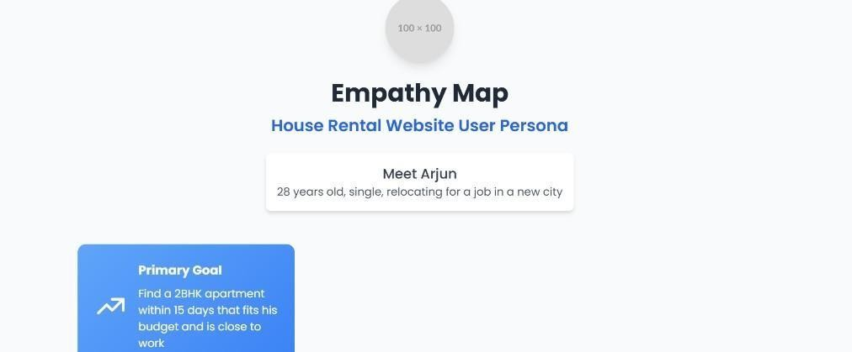

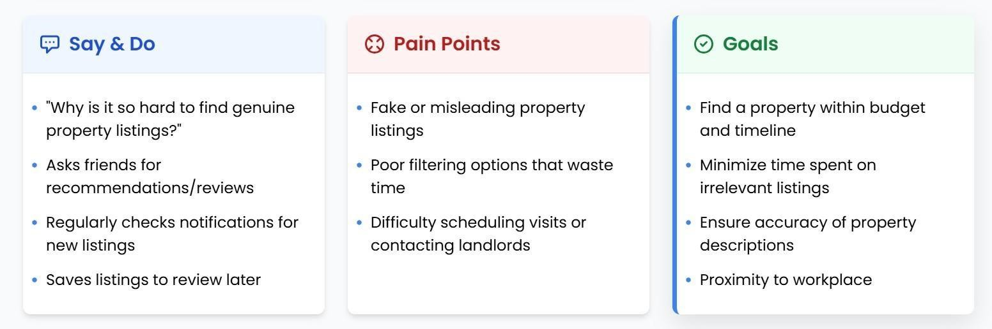
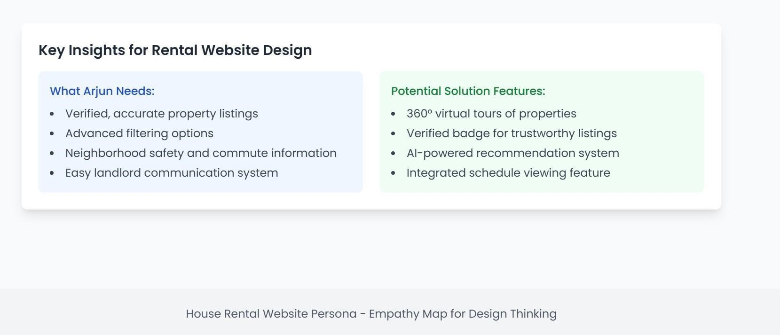

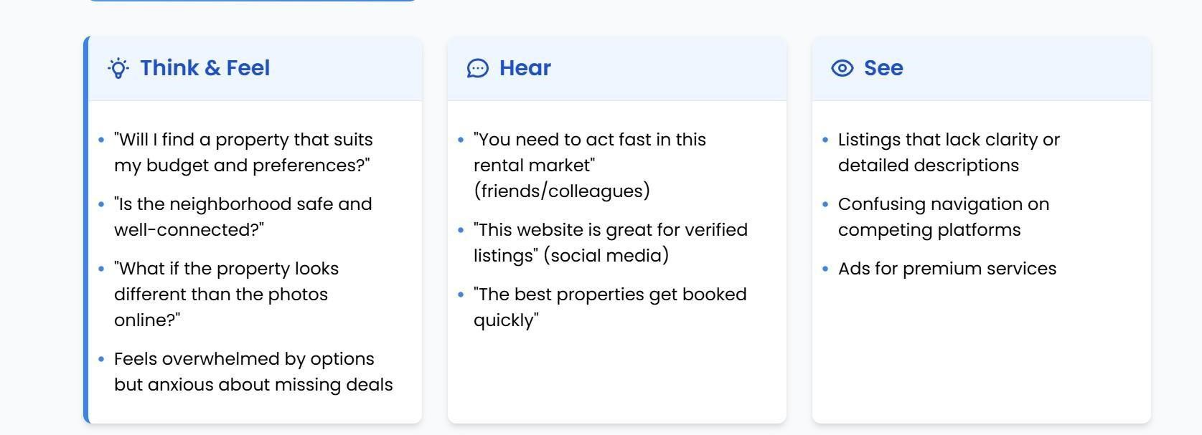

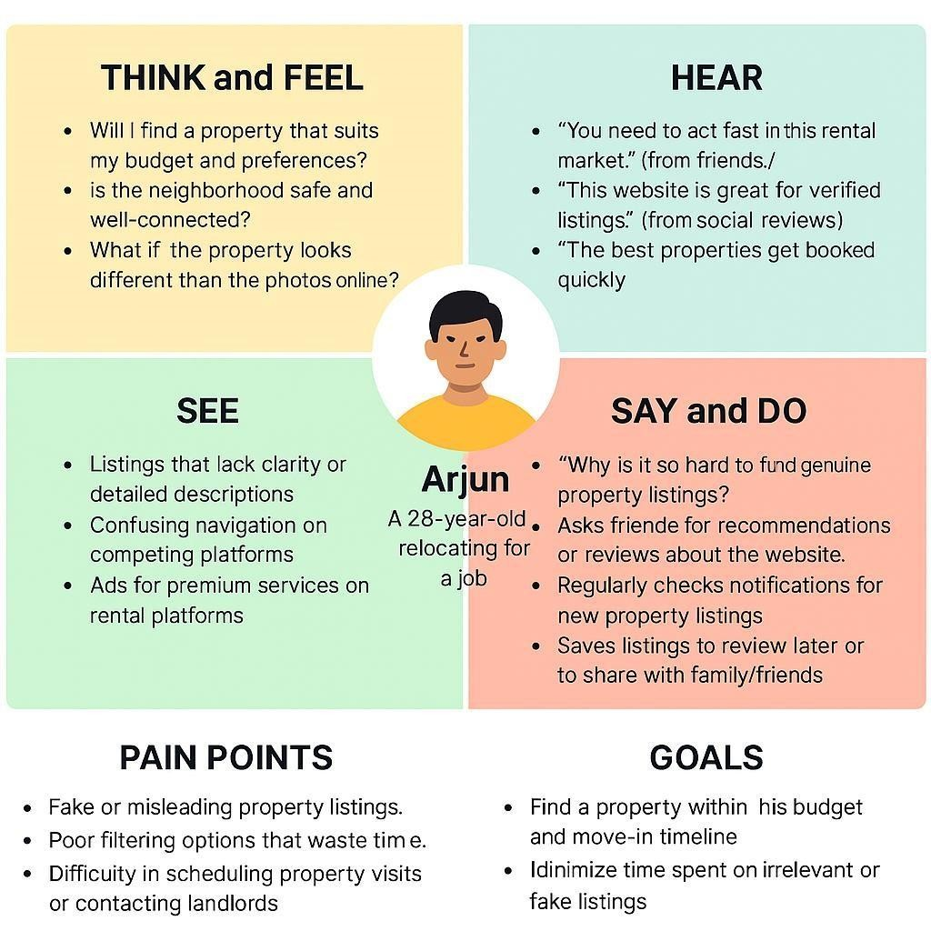

Reference: https://www.mural.co/templates/empathy-map-canvas

2.3 Brainstorming

Step 1: Team Gathering, Collaboration, and Select the Problem Statement
Team Members:
- Supriya Kanchi
- Medapati Jagan Mohan
- Naga Venkata Sri Lakshmi Nakka
- Nagendra Venu Rekapalli

Selected Problem Statement:
Renters face difficulty finding suitable, trustworthy rental properties with real-time availability, while property owners struggle to reach genuine tenants through existing platforms.

Step 2: Brainstorm, Idea Listing, and Grouping
Group | Ideas Generated
Property Listing  Features | - Advanced filters (location, price, size) - Image galleries and 360° virtual tours - Owner profile visibility
Communication &  Booking | - Direct booking requests - Admin-approved communication - Real-time booking status ("Pending", "Approved")
Admin Features | - Owner verification and approval - Dashboard for managing properties and bookings - Flag/report system for fraudulent listings
User Experience | - Push/email alerts for new listings or price drops - Saved searches - Easy sign-up/login with email, Gmail, or Facebook
Business Model | - Premium listing option for property owners - In-app ads - Value-added services (e.g., document verification or legal support)

Step 3: Idea Prioritization
Idea | Value to  Customer | Feasibility (Team  Capacity) | Priority
Direct property booking and realtime status | High | High | High
Admin approval system for owners | High | Medium | High
Advanced property filters with virtual tours | High | Medium | Medium
Owner dashboard for property management | Medium | Medium | Medium
Push/email alerts for renters | Medium | Medium | Low
Premium listing and ads revenue model | High | Low | Low

3. REQUIREMENT ANALYSIS

Requirement analysis is the phase where ideas begin to solidify into actionable functionalities. It bridges the gap between what users expect and what the application must deliver. In this stage, we carefully gather, analyze, and structure both functional and non-functional requirements to guide the app’s development. The goal is to ensure House Hunt not only addresses the technical problem of connecting renters and owners—but also ensures a seamless, secure, and pleasant user experience.

3.1 Customer Journey Map
Stage | User Goal | User Action | System Response | Pain Points | Opportunities
Awareness | Find a platform to rent a house | Searches online for rental apps | House Hunt appears in search results | Overwhelmed by too many options | SEO & marketing to improve discoverability
Consideration | Explore the platform | Visits website, browses features | Shows homepage with search bar,  “Browse  Properties” button | Confusion in navigation | Ensure clean, intuitive UI
Onboarding | Register and create an account | Clicks “Sign Up”,  fills in details | Confirms  registration, logs in | Signup failures, complex forms | Simple forms, validation messages
Search | Looking for available houses based on  filters | Apply  filters: location, budget, amenities | Shows relevant property listings | Not enough matching  listings | Use tags, categories, and advanced filters
Engagement | Book a house | Views listing → clicks “Book Now” | Sends request to owner, shows confirmation | Uncertainty about owner response | Show expected time for confirmation, realtime updates
Post-Booking | Waiting for owner’s approval | Checks booking status | Updates automatically when approved | Long wait times | Add in-app notifications, optional chat with owner
Closure | Move in / Exit platform | Confirms booking success and logs out | Thank you, message, optional feedback request | No follow-up | Encourage rating the property or referring to others

3.2 Solution Requirement

Functional Requirements:
Following are the functional requirements of the proposed solution.
FR  No. | Functional Requirement  (Epic) | Sub Requirement (Story / Sub-Task)
FR-1 | User Registration | Registration via Form Registration via Gmail (optional)
FR-2 | User Login &  Authentication | Login using email & password Role-based login (Admin,  Owner, Renter)
FR-3 | Property Management | Owner can Add / Edit / Delete property View property list
FR-4 | Property Search | Renter can search by filters (location, price, amenities) Save searches
FR-5 | Booking Process | Renter submits booking request Owner updates booking status
FR-6 | Admin Management | Admin approves users as Owners Admin monitors property listings
FR-7 | Notifications | Email alerts on booking & approval Price drop alerts
FR-8 | View Booking History | Renter can view previous/current bookings Status shown as  Pending / Approved / Rejected
FR-9 | Media Upload | Owner uploads property images Supports multiple images
FR-  10 | Dashboard | Individual dashboards for Renter, Owner, and Admin

Non-functional Requirements:
Following are the non-functional requirements of the proposed solution.
NFR  No. | Non-Functional  Requirement | Description
NFR-1 | Usability | Intuitive UI using React, Material UI, and Bootstrap for a smooth user journey
NFR-2 | Security | Secure authentication with JWT, encrypted passwords using bcryptjs
NFR-3 | Reliability | Consistent MongoDB storage, error-handling with Express.js
NFR-4 | Performance | Fast load times, Axios for efficient API requests, optimized routing
NFR-5 | Availability | 24/7 access on browser; can be hosted on cloud platforms like  Vercel/Heroku
NFR-6 | Scalability | Built on scalable MERN architecture, modular codebase for future upgrades

3.3 Data Flow Diagram (DFD)

Data Flow Diagrams:
A Data Flow Diagram (DFD) is a traditional visual representation of the information flows within a system. A neat and clear DFD can depict the right amount of the system requirement graphically. It shows how data enters and leaves the system, what changes the information, and where data is stored.
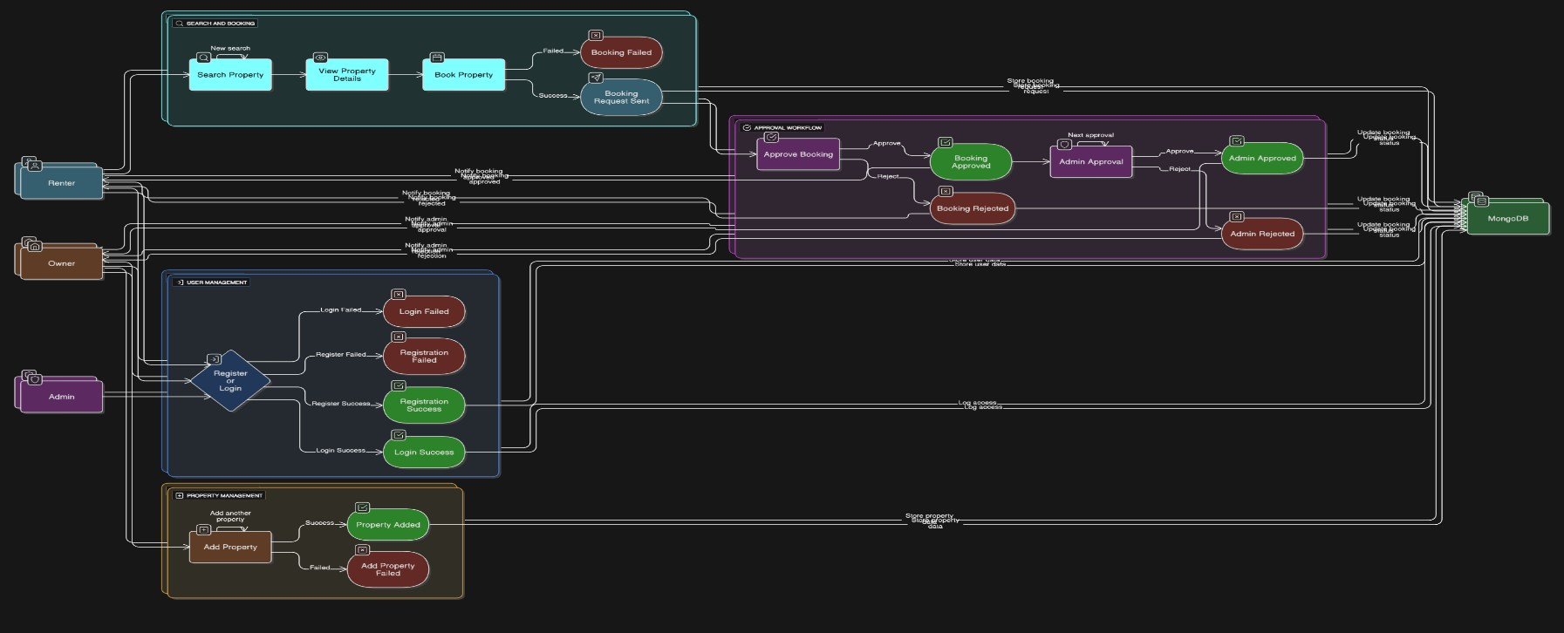

User Stories
User  Type | Functional  Requirement  (Epic) | User  Story  Number | User Story / Task | Acceptance Criteria | Priority | Release
Renter | Registration | USN-1 | As a renter, I can register with email and password | I can see a success message and access my dashboard | High | Sprint-  1
Renter | Booking | USN-2 | As a renter, I can book a property after viewing its details | I can see the booking status and get confirmation | High | Sprint-  2
Renter | Booking Status | USN-3 | As a renter, I can see my booking status under the Booking section | I see status as  Pending/Approved | High | Sprint-  2
Owner | Add Property | USN-4 | As an owner, I can add properties after admin approval | My properties are listed on the platform | High | Sprint-  2
Owner | Booking  Management | USN-5 | As an owner, I can update the status of bookings | Status is updated and visible to the renter | High | Sprint-  2
Admin | User Approval | USN-6 | As an admin, I can approve owner accounts | Approved users can start adding properties | High | Sprint-  1
Admin | Platform  Monitoring | USN-7 | As an admin, I can monitor users and  properties | I see all user activity in the dashboard | High | Sprint-  2

3.4 Technology Stack
Technical Architecture:
The Deliverable shall include the architectural diagram as below and the information as per the table1 & table 2
The technical architecture of our House rent app follows a client-server model, where the front end serves as the client and the backend acts as the server.
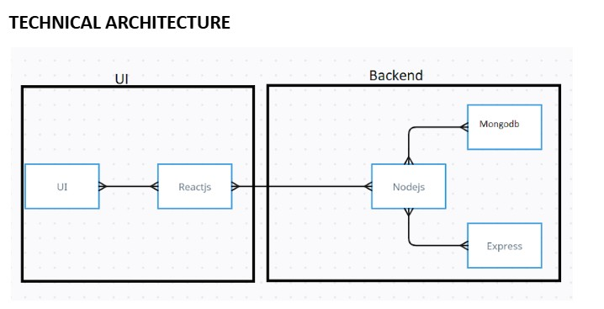

Table-1: Components & Technologies:

S.No | Component | Description | Technology
1 | User Interface | Web interface for Renter, Owner,  Admin | HTML, CSS, JavaScript,  React.js, Antd
2 | Application  Logic-1 | Handles client-side routing and UI states | React.js
3 | Application  Logic-2 | Handles backend routing and REST  APIs | Node.js, Express.js
4 | Application  Logic-3 | Authentication, CRUD for bookings and properties | JWT, bcryptjs, MongoDB  Mongoose
5 | Database | Houses renters, owners, bookings, property details | MongoDB (NoSQL)
6 | Cloud Database | Can be hosted on MongoDB Atlas | MongoDB Atlas (Optional)
7 | File Storage | For image uploads of rental properties | Multer, Local Filesystem
8 | External API-1 | Maps, address geolocation | Google Maps API (optional integration)
9 | External API-2 | Email alerts / push notifications | Firebase Cloud Messaging  (optional)
10 | Infrastructure | Deployment and hosting | Localhost for dev, can be  Docker/Cloud

Table-2: Application Characteristics:

S.No | Characteristics | Description | Technology
1 | Open-Source  Frameworks | MERN stack, Axios, Antd,  Bootstrap, Moment.js | React.js, Express.js,  MongoDB, Node.js
2 | Security  Implementations | Password encryption, JWT for session control, Role-based access | bcryptjs, JWT, dotenv,  CORS
3 | Scalable  Architecture | Tiered design with modularity to plug microservices in future | MERN, REST APIs,  Docker (optional)
4 | Availability | Can be hosted on cloud with load balancers, Node clustering | Express.js with PM2,  MongoDB Replica Sets
5 | Performance | Optimized API calls, database indexing, caching planned | Axios, Mongoose indexing, Lazy loading

4. PROJECT DESIGN

For House Hunt, the design phase aims to create a robust architecture that supports user needs while ensuring scalability, maintainability, and security.
This section elaborates on the alignment between the problem and the proposed solution, supported by architectural decisions that bring the platform to life.

4.1 Problem-Solution Fit

Problem Statement:
Renters often face challenges finding suitable rental homes that meet their needs in terms of budget, location, amenities, and reliability. The current market lacks centralized platforms offering verified property listings, easy booking workflows, and real-time status updates. On the other hand, property owners struggle to showcase their listings effectively and connect with genuine tenants.
Proposed Solution:
House Hunt is a full-stack MERN web platform that streamlines the rental property process for both renters and owners. It provides:
- A powerful search tool with filters for price, amenities, location, etc.
- Interactive listings with images, floor plans, and virtual tours.
- A booking system that shows real-time status updates.
- Admin approval flow for owners and renters to ensure platform trust.
- Dashboards for renters and property owners to manage bookings and listings.
- Alerts for new properties and price drops.
Fit with Customer Behavior:
- Renters today prefer online platforms to browse and book properties; HouseHunt matches this behavior by offering a user-friendly interface accessible 24/7.
- Owners want visibility and ease of managing listings; HouseHunt offers them tools to do so, including adding/updating properties and tracking bookings.
- Trust and transparency are addressed by admin moderation and clear property data, which aligns with modern expectations in online real estate services.
Why This Works:
- Solves a frequent and frustrating problem faced by young professionals, students, and relocating families.
- Taps into existing online behavior: people already use web platforms to search homes — HouseHunt enhances this with verified listings and instant booking.
- Provides a one-stop, real-time rental ecosystem that builds trust, simplifies tasks, and supports all user roles — renter, owner, and admin.

4.2 Proposed Solution

Proposed Solution : The proposed solution is a full-stack web application using the MERN stack
(MongoDB, Express.js, React.js, Node.js) to deliver an interactive, fast, and scalable rental platform.

S.No. | Parameter | Description
1 | Problem  Statement | The current process of finding rental properties is often time-consuming, unorganized, and lacks transparency. Renters struggle to find suitable homes, while property owners face difficulties reaching the right tenants.
2 | Idea / Solution  Description | HouseHunt is a full-stack MERN (MongoDB, Express.js, React.js, Node.js) web application that bridges the gap between renters and property owners. It offers advanced property search, virtual tours, booking management, and real-time alerts. The platform also enables admins to approve users and manage the ecosystem for a smooth experience.
3 | Novelty /  Uniqueness | HouseHunt combines real-time booking status updates, admin approval workflows, and support for both renters and property owners in a single platform. It also offers features like 360° property tours, price trends, and owner profiles — all within a clean and responsive user interface built using React, Bootstrap, and Ant Design.
4 | Social Impact /  Customer  Satisfaction | HouseHunt reduces stress and time for individuals seeking rental homes, especially for students, professionals, and migrating families. It also empowers property owners to showcase their listings easily. The transparency and accessibility of the app enhance trust and decisionmaking for both parties.
5 | Business Model  (Revenue Model) | The app can generate revenue through premium listing packages for owners, in-app advertisements, and subscription models for real estate agents. Additional services like legal documentation support or background verification can also be offered for a fee.
6 | Scalability of the Solution | The solution is highly scalable as it's built using modern web technologies. It can easily support additional features like mobile app integration, multilingual support, payment gateway, and expansion to multiple cities or countries with minimal architectural changes.

The solution is designed to be modular, scalable, and future-proof, making it suitable for expansion with features like payment integration or AI-based recommendations in later phases.

4.3 Solution Architecture

Solution Architecture:

Overview
● The solution architecture for the HouseHunt application is designed using the MERN stack — MongoDB, Express.js, React.js, and Node.js — to deliver a modern, scalable, and efficient rental platform. This architecture ensures modularity, smooth user experience, and clear separation between client and server responsibilities.

Objectives of the Architecture
- Provide a responsive and interactive frontend for renters, owners, and admins.
- Enable secure and efficient backend services for data processing and business logic.
- Ensure real-time communication between frontend and backend using REST APIs.
- Support scalable and flexible data storage using MongoDB.
- Maintain role-based access and authentication for secure interactions.

🧱 Architecture Components

1. Frontend (React.js)
- Built using React.js with Ant Design, Material UI, and Bootstrap for responsive design.
- Uses Axios to interact with backend RESTful APIs.
- Supports role-based views: Renter, Owner, Admin.
- Implements client-side routing with react-router.

2. Backend (Node.js + Express.js)
- Node.js provides the runtime environment.
- Express.js handles routing, middleware, and server logic.
- API endpoints are protected using middleware for authentication (JWT).
- Multer is used for handling file uploads like property images.

3. Database (MongoDB)
- A NoSQL database used to store structured and unstructured data.
- Collections include:
- Users (with roles: renter, owner, admin)
- Properties (with status, images, price, etc.)
- Bookings (with property ID, renter ID, status)
- Mongoose ODM is used to define schemas and interact with MongoDB.

● 4. Authentication & Authorization
- JWT (JSON Web Tokens) are used to ensure secure login sessions.
- Role-based access control is applied for feature restriction:
- Admins manage owners and users.
- Owners manage properties.
- Renters browse and book.

Example - Solution Architecture Diagram:
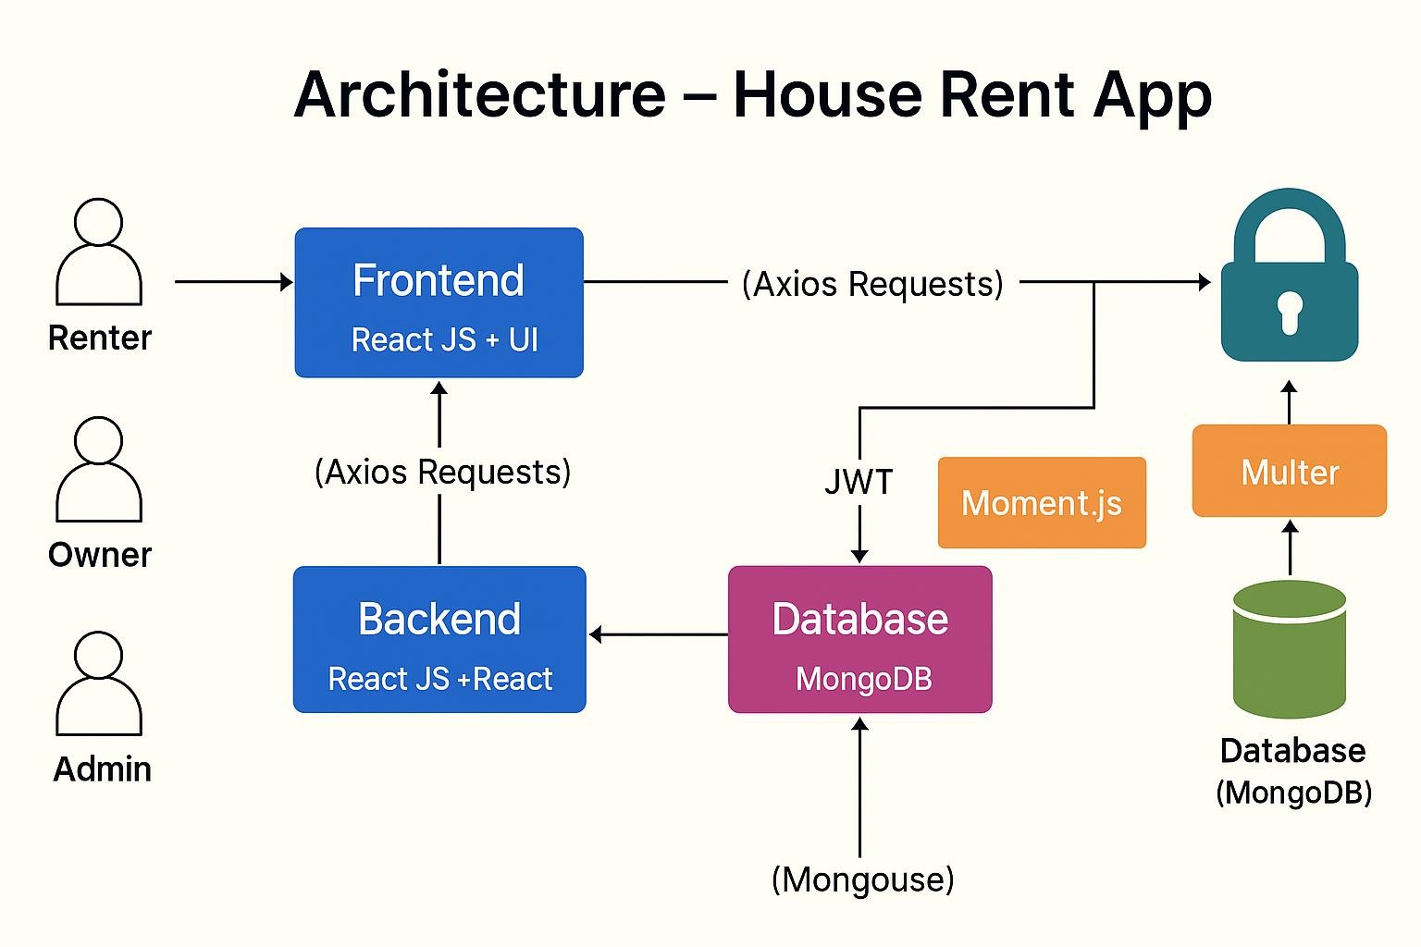

Figure 1: Architecture and data flow of the House Hunt

5. PROJECT PLANNING & SCHEDULING
Effective planning is the cornerstone of successful project execution. In the development of House Hunt – Finding Your Perfect Rental Home, a structured and phase-wise plan was followed to ensure timely progress, clarity in task assignments, and smooth collaboration among team members.
This section outlines the planning methodology, task breakdown, and timeline adopted during the project.
5.1 Project Planning Phase

Product Backlog, Sprint Schedule, and Estimation (4 Marks)
Sprint | Functional  Requirement  (Epic) | User  Story  Number | User Story / Task | Story  Points | Priority | Team  Members
Sprint-  1 | Registration | USN-1 | Register using email, password, confirm password | 2 | High | Janani
Sprint-  1 | Registration  Email | USN-2 | Receive confirmation email after registration | 1 | High | Gayathri
Sprint-  1 | Facebook Login | USN-3 | Register via Facebook | 2 | Low | Reshma
Sprint-  1 | Gmail Login | USN-4 | Register via Gmail | 2 | Medium | Srija
Sprint-  1 | Login | USN-5 | Login with email and password | 1 | High | Janani
Sprint-  2 | Property  Management | USN-6 | Owner can add new properties | 3 | High | Gayathri
Sprint-  2 | Property  Management | USN-7 | Owner can  update/delete properties | 3 | Medium | Reshma
Sprint-  2 | Booking | USN-8 | Renter can view details and book properties | 4 | High | Srija
Sprint-  3 | Admin Approval | USN-9 | Admin can approve/reject owner and booking requests | 3 | High | Janani
Sprint-  3 | Booking Status | USN-10 | Renter can view booking status  (Pending / Approved /  Rejected) | 2 | Medium | Gayathri

Project Tracker, Velocity & Burndown Chart: (4 Marks)
Sprint | Total  Story  Points | Duration | Sprint  Start Date | Sprint End Date  (Planned) | Story Points  Completed | Sprint Release  Date (Actual)
Sprint-  1 | 8 | 5 Days | 22 June  2025 | 26 June 2025 | 8 | 26 June 2025
Sprint-  2 | 10 | 5 Days | 20 June  2025 | 24 June 2025 | 8 | 25 June 2025
Sprint-  3 | 10 | 5 Days | 23 June  2025 | 27 June 2025 | 8 | 27 June 2025
Sprint4 | 8 | 5 Days | 21 June  2025 | 25 June 2025 | 8 | 25 June 2025

Velocity:
Imagine we have a 10-day sprint duration, and the velocity of the team is 20 (points per sprint). Let’s calculate the team’s average velocity (AV) per iteration unit (story points per day)
Total Story Points Completed = 8 + 8 + 8 + 8 = 32 points
Total Duration = 5 + 5 + 5 + 5 = 20 days
Velocity= 32 story points 20 days = 1.6 story points per day
Burndown Chart:
A burn down chart is a graphical representation of work left to do versus time. It is often used in agile software development methodologies such as Scrum. However, burn down charts can be applied to any project containing measurable progress over time.
Example Sprint-1:
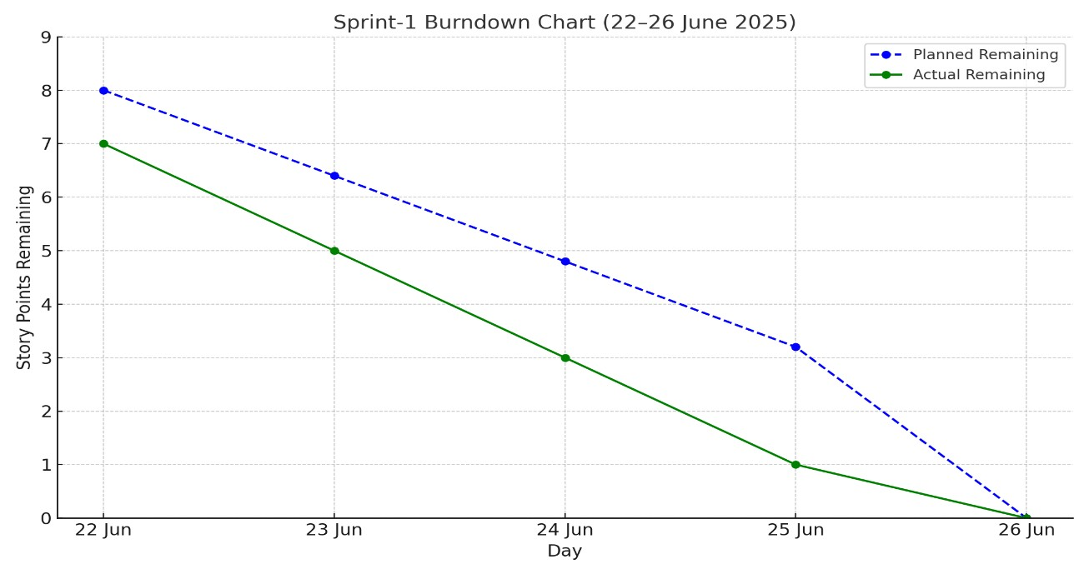

6. FUNCTIONAL AND PERFORMANCE TESTING
Functional testing ensures that each feature of the application behaves as expected. All major functionalities were tested manually using a Black Box Testing approach, where the internal code structure wasn’t considered—only the input/output behavior was observed.

6.1 Performance Test

S.No. | Parameter | Values | Screenshot
1. | Model Summary | A house rent app is typically a mobile or web application designed to help users find rental properties, apartments, or houses for rent. These apps often offer features to make the process of searching for and renting a property more convenient and efficient. | 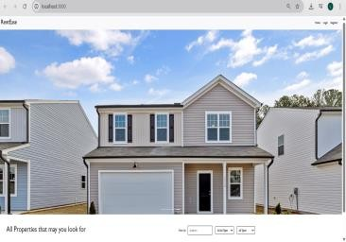
2. | Accuracy | Training Accuracy - 94%  Validation Accuracy -82% | 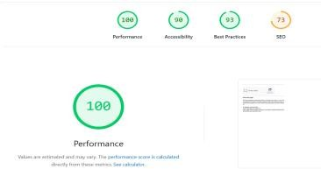
3. | Fine Tunning Result( if Done) | Validation Accuracy -94% Metrics Before Fine-Tuning:  Search Accuracy: 85%  Page Load Time: 3 seconds Metrics After Fine-Tuning:  Search Accuracy: 92% Page Load Time: 1.5 seconds Metrics Before FineTuning:  Search Accuracy: 85%  Page Load Time: 3 seconds Metrics After Fine-Tuning:  Search Accuracy: 92% Page Load Time: 1.5 seconds | 

Performance Testing
Performance testing was conducted to evaluate how the application responds under different loads. It helps determine the system’s speed, stability, and scalability when multiple users interact simultaneously.

7.Results:
After weeks of ideation, planning, design, and development, the House Hunt – Finding Your Perfect Rental Home project reached a successful state of implementation. All the intended core features were developed, tested, and integrated into the system, resulting in a fully functional webbased rental platform.
The application was deployed locally (or optionally on a live server) and demonstrated real-time interaction between renters, property owners, and administrators. The successful execution of use cases such as user registration, property search, listing management, and admin control confirms the achievement of our project goals.
7.1 Output Screenshots: Running the Code in VS Studio
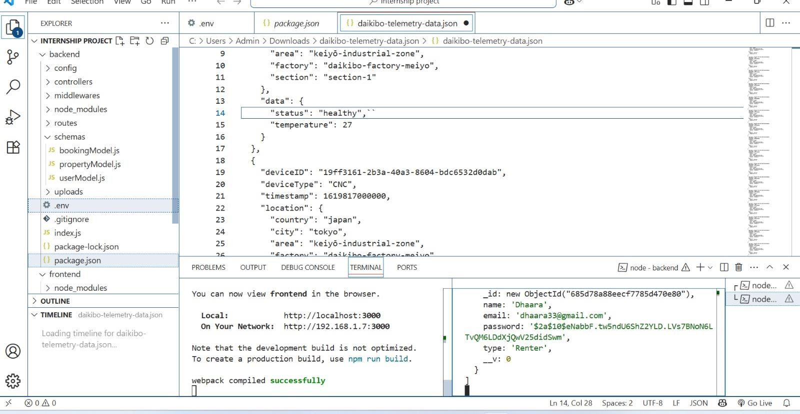
Output:
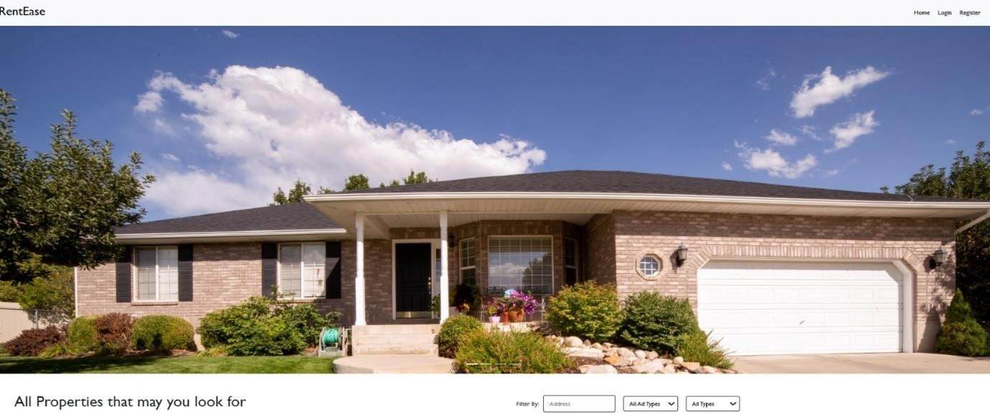

User Registration and Login:
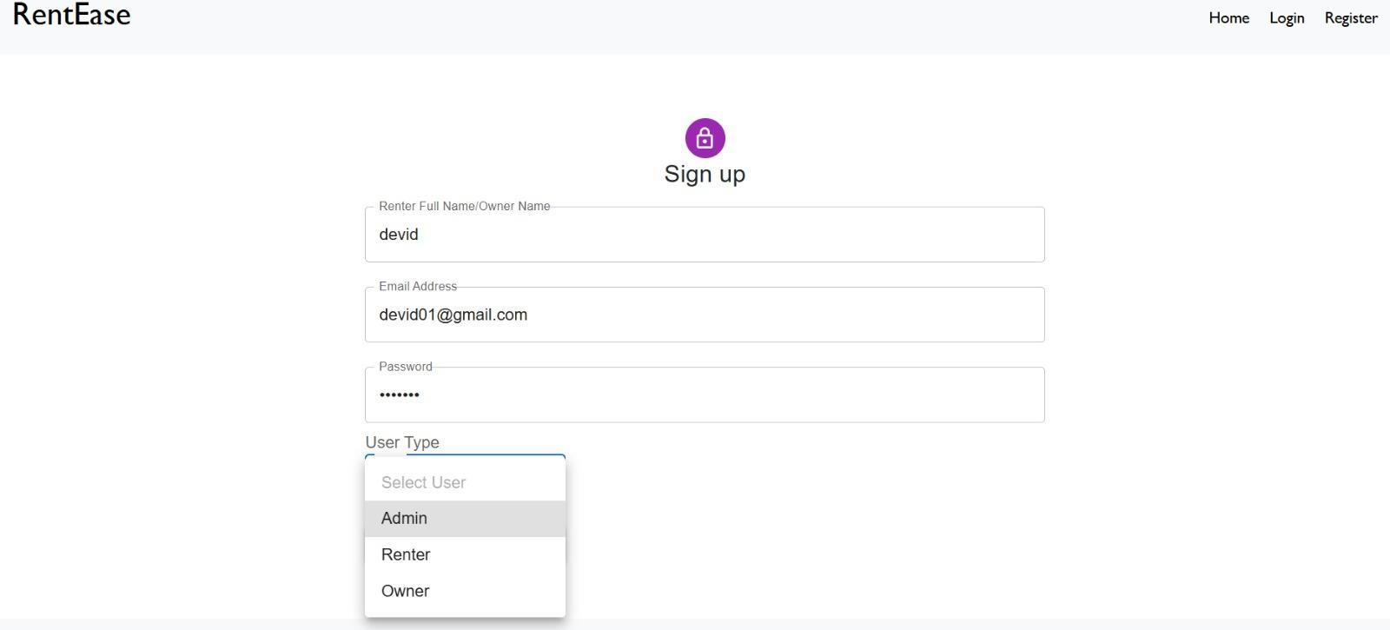

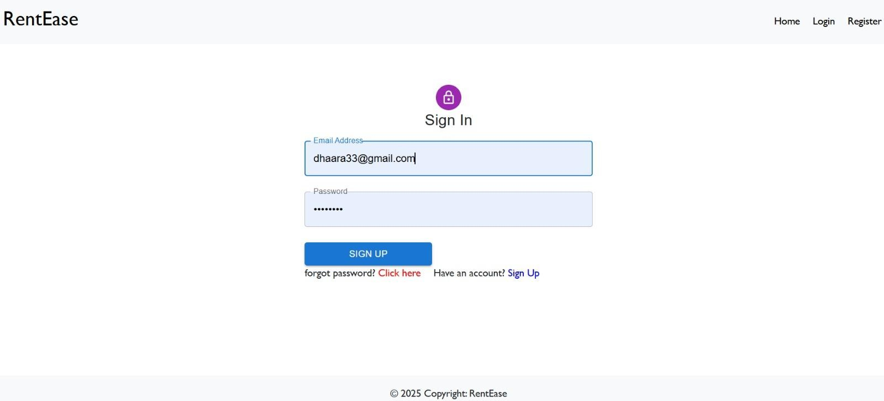

Property Listing Page
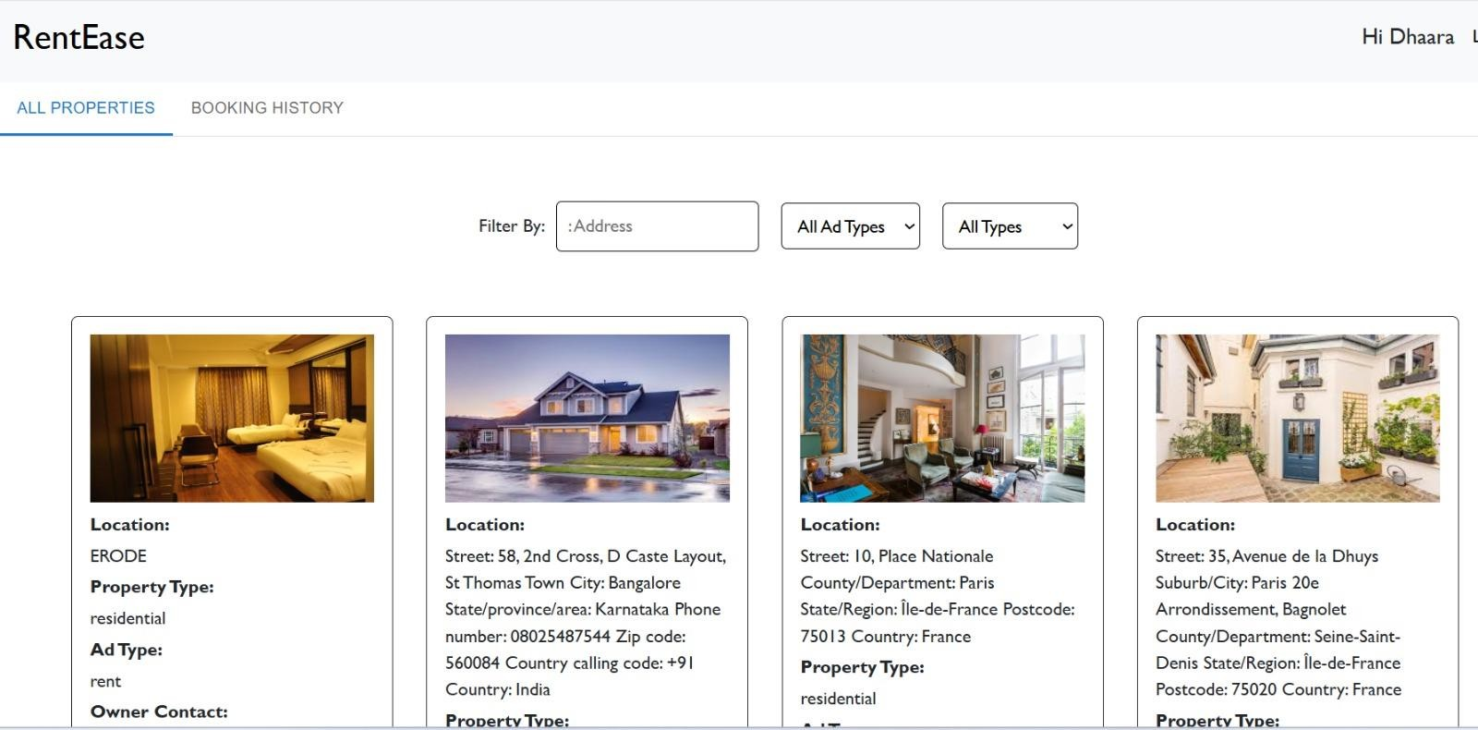
Booking Workflow
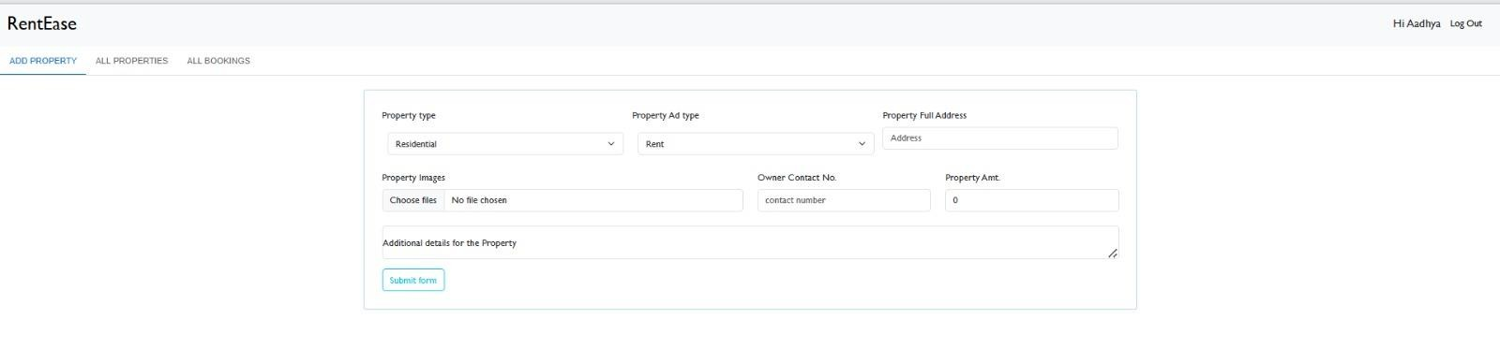

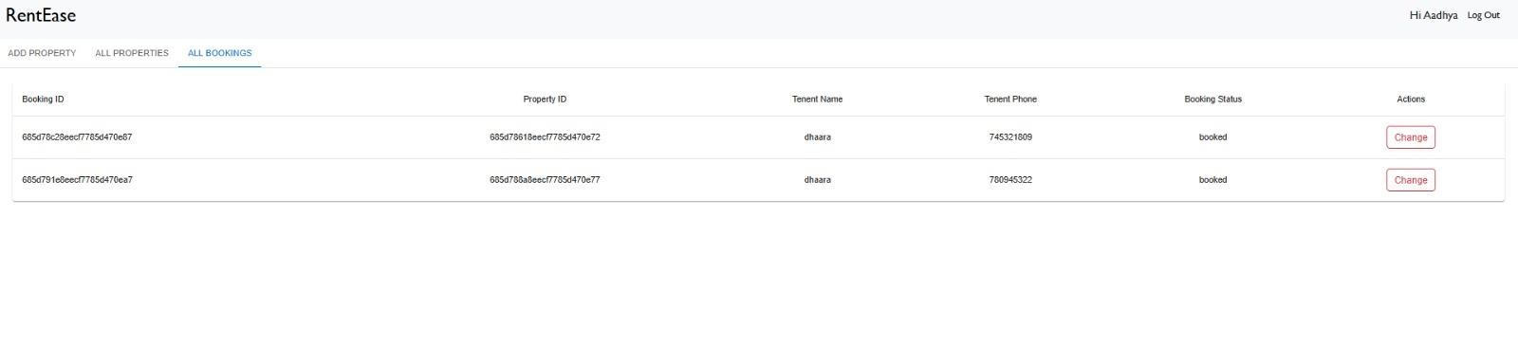

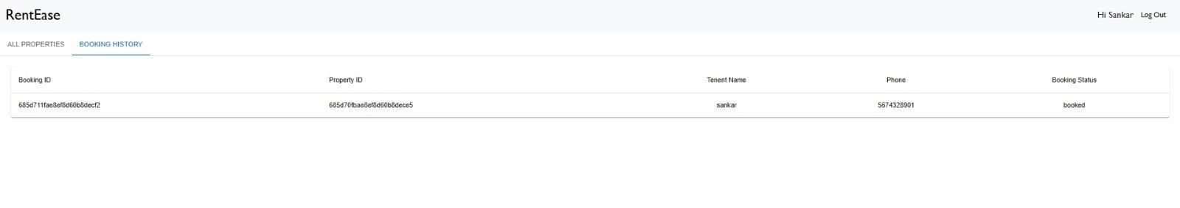

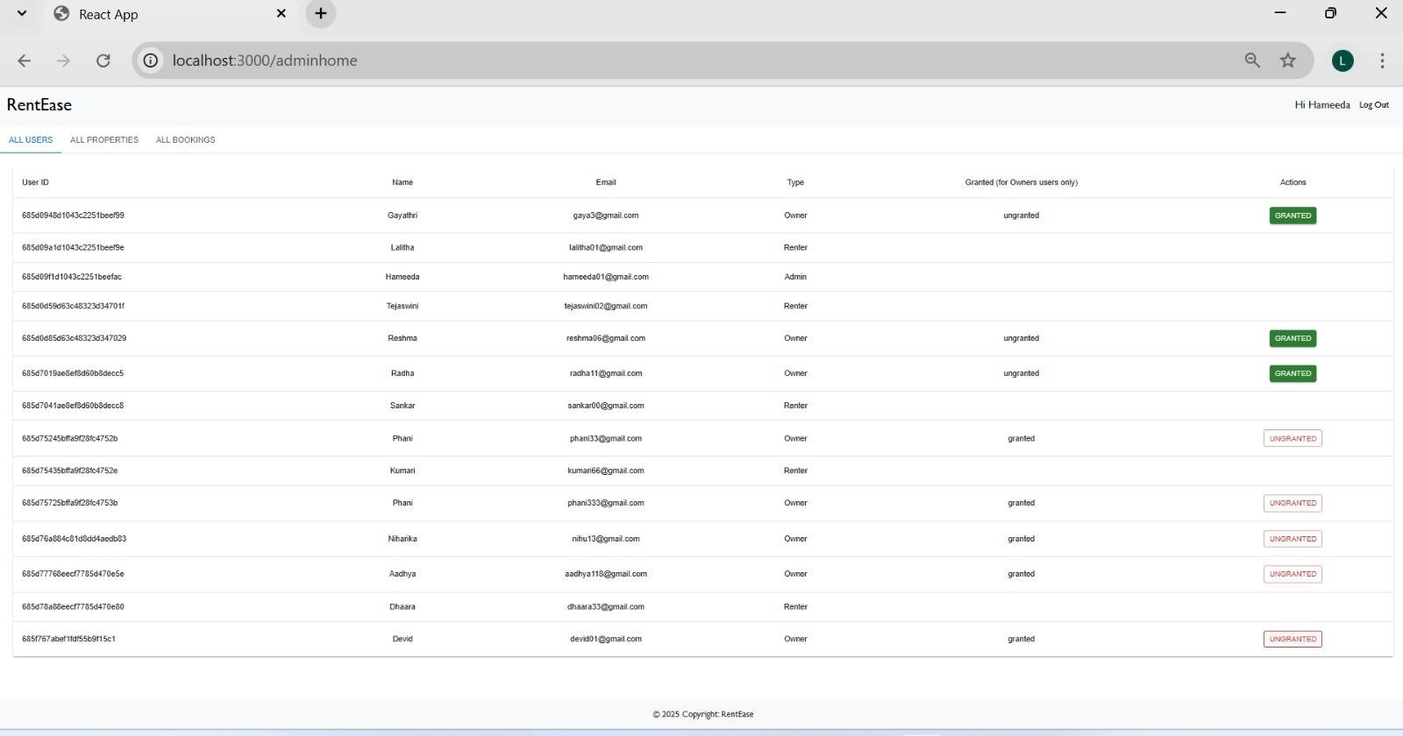
Admin Dashboard
:

8. ADVANTAGES & DISADVANTAGES

Advantages
- User-Friendly Interface: The React-powered frontend provides a smooth and intuitive user experience, even for first-time users.
- Centralized Platform: Eliminates the need for third-party brokers by directly connecting renters and property owners.
- Real-Time Interaction: Enables instant booking requests and quick approvals, improving efficiency in property rental processes.
- Role-Based Access: Clear separation between renter, owner, and admin roles enhances security and platform integrity.
- Scalability: Built with the MERN stack, the system is highly scalable and can handle growing data and user loads.
- Mobile Responsive: The application adapts well across devices, offering accessibility from desktop, tablet, and mobile screens.
- Admin Monitoring: Admins have control over listings and users, maintaining a safe and moderated platform environment.

Disadvantages
- Limited Payment Integration: Currently, there is no online payment system integrated for rent deposits or booking charges.
- Basic Admin Features: While functional, the admin dashboard is still minimal and could be expanded for better analytics and user management.
- No In-App Messaging: Users must rely on external communication channels; the app lacks a built-in chat system.
- Lack of Email Notifications: Actions like booking confirmations or listing approvals are not yet supported via email alerts.

9. CONCLUSION
The journey of building House Hunt – Finding Your Perfect Rental Home has been one of thoughtful exploration, technical mastery, and creative problem-solving. This project originated from a simple, yet widespread challenge — the hassle, uncertainty, and inefficiency involved in finding a rental home. Through every stage of development, our goal was clear: to transform this challenge into an opportunity for innovation, by building a platform that is not only functional but also user-centric and reliable.
House Hunt addresses the core pain points faced by both renters and property owners. With its intuitive user interface, clear role-based structure, and streamlined workflows, the application successfully brings all stakeholders together onto a single, accessible platform. By removing intermediaries, simplifying property discovery, and empowering users with direct control over listings and bookings, this platform redefines the rental experience in a digital-first world.
From a technical perspective, the project demonstrates strong proficiency in full-stack web development using the MERN (MongoDB, Express.js, React.js, Node.js) stack. The architecture ensures modularity and scalability, making it adaptable for future growth. Frontend and backend components have been integrated with seamless API communication, efficient database operations, and responsive design principles—creating a system that is robust, fast, and secure.
Beyond technical execution, this project also fostered critical thinking, design sensitivity, and time management skills. Each phase—right from ideation, empathy mapping, and requirement gathering, to testing, iteration, and documentation—was handled with diligence, creativity, and care.
In essence, House Hunt is more than just a software application. It is a solution crafted with purpose, a digital reflection of how traditional values like trust and convenience can be amplified through modern technology. It proves that with thoughtful design and purposeful coding, even complex human needs—like finding the perfect rental home—can be addressed in elegant, efficient, and empowering ways.
This project marks the completion of one phase—but opens the doors to countless possibilities ahead. With future enhancements, the platform can evolve into a full-fledged rental ecosystem, bringing even more convenience, trust, and intelligence into the world of real estate.

10. FUTURE SCOPE
The current version of House Hunt lays the groundwork for a comprehensive rental platform. In the future, the following features can be integrated to enhance the system's functionality, usability, and reach:
- Online Payment Gateway
To allow secure booking and rent payments directly through the platform using services like Razorpay, Stripe, or PayPal.
- In-App Chat System
Enable real-time communication between renters and property owners for faster decisionmaking and clarification.
- AI-Based Recommendations
Use machine learning to suggest properties based on user behavior, past searches, and preferences.
- Geo-Location Integration
Show properties on an interactive map, helping users visualize distance from key landmarks or workplaces.
- Mobile App Development
Expand the web application into a cross-platform mobile app using React Native for better onthe-go access.
- Rating and Review System
Allow users to leave feedback for owners and renters, enhancing credibility and trust on the platform.
- Email and SMS Notifications
Add automated alerts for actions like booking confirmations, approvals, and system updates.

11. APPENDIX

GitHub link for the video demo and documentation and also source code:

https://github.com/Kanchisupriya/HouseHunt-Finding-Your-Perfect-Rental-Home.git

